DATE:01.08.25
TASK 2
Hill climbing algorithm for Heuristic search

Implementation of Hill climbing algorithm for Heuristic search approach using following constraints in python.
i. Create a function generating all neighbours of a solution
ii. Create a function calculating the length of a route
iii. Create a random solution generator
iv. Create a Travelling salesman problem
Tools- Python, Online Simulator - https://graphonline.ru/en/

PROBLEM STATEMENT: CO1 S3

Imagine a mountain climber trying to reach the highest point of a mountain range. The terrain is represented as a 1D array of elevations (like hill heights at different points). The climber starts at a random position and uses the hill climbing heuristic to move only to higher neighboring positions. The goal is to find the local or global maximum elevation

DATE:01.08.25
TASK-2
Implementation of Hill climbing algorithm for Heuristic search approach

AIM
To implement the Hill Climbing algorithm as a Heuristic Search technique for solving optimization problems, where the objective is to find the best possible solution (maximum or minimum) based on a heuristic value.

ALGORITHM
- Start at a random position on the terrain.
- Check the neighboring positions (left and right).
- Compare the elevation of the current position with neighbors.
- Move to the neighbor with the highest elevation, if it’s higher than the current one.
- Repeat steps 2–4 until no neighbor has a higher elevation.
- Stop – you’ve reached a peak (highest nearby point).

PROGRAM
Hill Climbing for Peak Finding

import random

# i. Function to generate neighbors (left and right positions)
def generate_neighbors(position, terrain):
neighbors = []
if position > 0:
neighbors.append(position - 1)
if position < len(terrain) - 1:
neighbors.append(position + 1)
return neighbors

# ii. Heuristic function: height of the terrain at a given position
def heuristic(position, terrain):
return terrain[position]

# iii. Random starting point
def get_random_position(terrain):
return random.randint(0, len(terrain) - 1)

# Hill Climbing Algorithm
def hill_climbing(terrain):
current_position = get_random_position(terrain)
current_value = heuristic(current_position, terrain)

print(f"Starting at position {current_position} with elevation {current_value}")

while True:
neighbors = generate_neighbors(current_position, terrain)
best_neighbor = current_position
best_value = current_value

for neighbor in neighbors:
neighbor_value = heuristic(neighbor, terrain)
if neighbor_value > best_value:
best_value = neighbor_value
best_neighbor = neighbor

if best_value == current_value:
break # No better neighbor found — local maximum
else:
current_position = best_neighbor
current_value = best_value
print(f"Moving to position {current_position} with elevation {current_value}")

print(f"Reached peak at position {current_position} with elevation {current_value}")

# Example terrain (elevations at different points)
terrain = [10, 20, 15, 25, 30, 40, 35, 25, 50, 45]

# Run the algorithm
hill_climbing(terrain)

OUTPUT

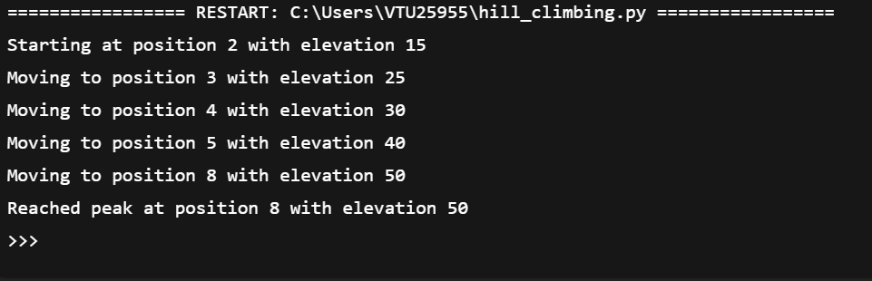

RESULT
Thus the implementation of Hill Climbing algorithm as a Heuristic Search technique for solving optimization problems problem using python was successfully executed and output was verified.

